Name:
Ahmed Awan
2024-CET-22
Roll No:
Group:
Computer Engineering Technology
2024-2028
Section:
Submitted To:
Madam Fatima Khwaja


My Design:
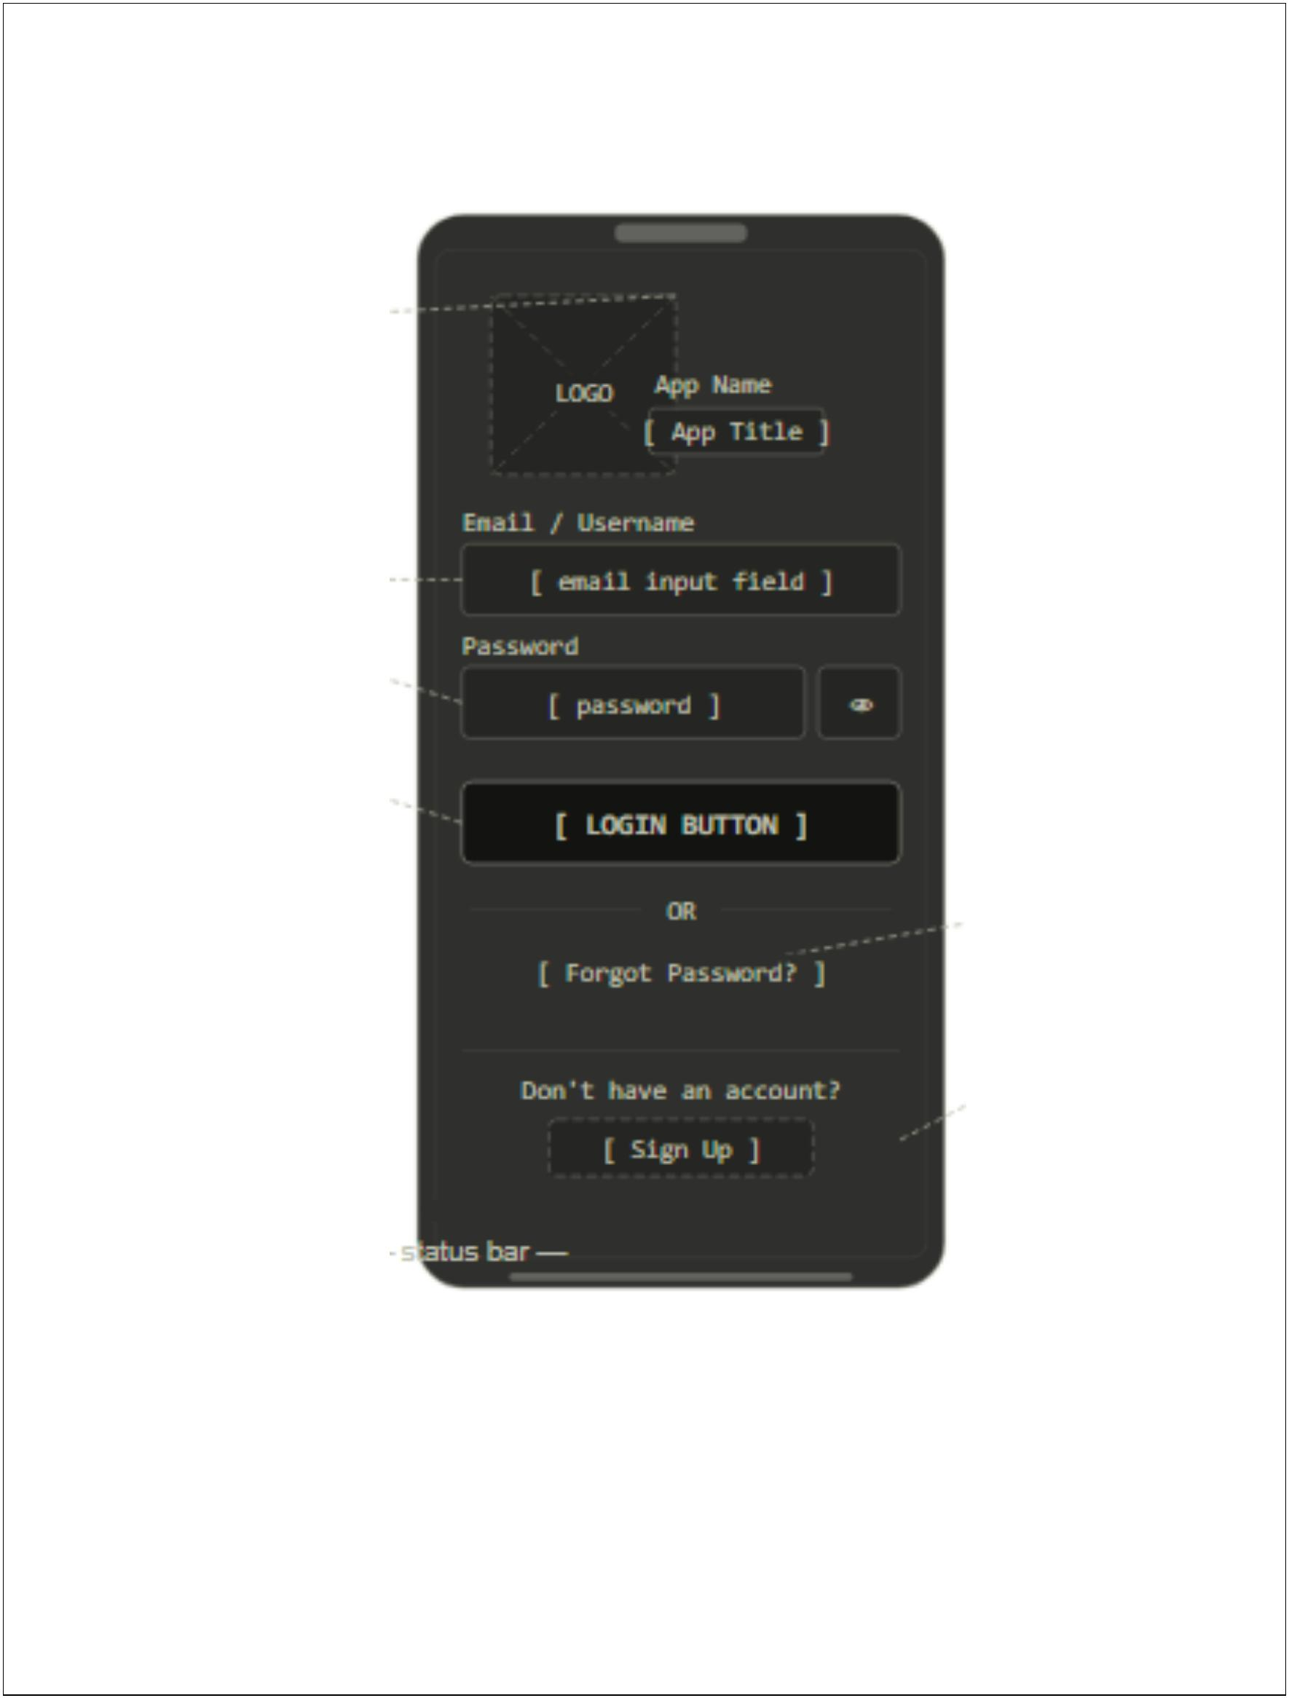

UX Explanation:
The logo and app title are placed at the top-center to establish brand identity immediately,
giving the user confidence they are in the right app before entering credentials.
The password field includes a show/hide toggle (eye icon) to reduce errors during entry,
improving usability especially on small mobile screens.
The Login button spans the full width and is visually dominant, creating a clear visual hierarchy
that guides the user's eye and reduces decision fatigue.
Forgot Password and Sign Up are placed below the primary action in a secondary style, keeping
them accessible without competing with the main login flow.


